**FALL-2018**

**ONLINE SHOPPING SYSTEM PROJECT**



**A project (SE133: Software Development Capstone Project using C) submitted in fulfillment of the requirements for the degree of BSc in Software Engineering**

**DEPARTMENT OF SOFTWARE ENGINEERING**

**DAFFODIL INTERNATIONAL UNIVERSIRTY**

**Name: Abu Kowshir Bitto**

**ID: 181-35-2379**

Page – I

**DECLEARATION OF PROJECT**

|  |  |
| --- | --- |
| Author Full Name | : Abu Kowshir Bitto |
| Date of Birth | : 10th April 1999 |
| Title of Project | : Online Shopping System |
| Academic Session | : 2018 |
|  |  |

I, the author, hereby declare that the project becomes the property of Daffodil International University (DIU) and to be placed at the department of Software Engineering. I also give permission to the DIU to reproduce this project in whole or in part for the purpose of research or academic exchange only.

Page – II

|  |  |
| --- | --- |
|  | CERTIFIED BY |
| SIGNATURE | SIGNATURE OF SUPERVISOR |
| 181-35-2379 | Md. Shohel Arman Shuvo |
| STUDENT ID : | NAME OF SUPERVISOR |
|  |  |
| Date: | Date: |

Page – III

**AKNOWLEDGEMENT**

First all thanks to almighty Allah for giving the strength to start and complete my project. Secondly I want to thanks Daffodil International University for giving me a great chance to hence myself and also developing this project, thirdly I want to appreciate my department of software engineering especially our honorable head **Dr. Touhid bhuiyan** and my dear teachers for excellence teaching and providing such incredible study. This project is called Online Shopping System and it’s about new way to buy valuable product safely. I am very proud and happy to make this project and remark one of my dreams done

I also want to thanks my dear parents for their encouragement and endless support and my friends who support to do this project.

Finally, I want appreciate my dear teacher **Md Shohel Arman** for his excellence teaching and advices during my study of his course as well as my project.

Thanks

Abu Kowshir Bitto

Page – IV

**TABLE OF CONTENTS**

PROJECT DECLARATION …………………………………………….II

AKNOWLEDGEMENT……………...................................... IV

TABLE OF CONTENTS………………………………………………… V

LIST OF ABREVIATIONS……………………………………………… VIII

LIST OF SYMBOLS……………………………………………………… VIII

ABSTARCT………………………………………………………………… IX

Page –V

**CHAPTER 1: INTRODUCTION**

1.1 Project over view………………………………………………page 1

1.2 Obstacles …………………………………………………………page 1

1.3 Technology Requirement…………………………………page 2

1.4 Milestone and reporting…………………………………. page 3

1.5 Support……………………………………………………………page 4

1.6 Training……………………………………………………………page 4

1.7 Pricing ……………………………………………………………. page 4

1.8 Contact Me………………………………………………………page 4

1.9 Requirement Elicitation…………………………………… page 5

Page – VI

**CHAPTER 2: PROJECT METHADOLOGY**

2.1 USER MANUAL……………………………………………………. page 6

2.1.1 ADMIN……………………………………………………………. page 7

2.1.2 CUSTOMER……………………………………………………. page 10  
2.1.3 EXIT………………………………………………………………… page 14  
2.2 DESIGN AND IMPLEMENTATION……………………….. page 15  
2.3 SOFTWARE REQUIREMENT SPECIFICATION………. page 16  
2.4 USE CASE………………………………………………………….. page 17  
2.5 USE CASE DESCRIPTION……………………………………. page18

**CHAPTER 3: CONCLUSIONS AND RECOMMENDATIONS**

**REFERENCES**

Page – VII

**4. LIST OF ABBREVIATIONS**

In my project I have used all this abbreviation

**Add** = Address

**Names** = Name

**User** = Username

**Pass** = Password

**5. LIST Design Symbols**

**-**

**=**

**>**

**<**

Page – VIII

**6.ABSTRACT**

Background: Online Shopping system is a very important for any people for buy their valuable product and it done very easily .

Objective: The main objective of this project is to maintain people valuable time and safely get their product.

Method: At first, admin add product and customer see the product and order for buy and all data has been collected then it’s implemented in the project.

Result: Since this project is created people can easily buy their product.

Conclusion: I hope this project will help people to save their valuable time.

Page – IX

**CHAPTER 1: INTRODUCTION**

1. **Project Over view**

Online Shopping System project it is about help people to buy their product. It saves people valuable time. Here admin will login in admin page with admin name and password. Admin will see which customer order product and which product customer order Customer will sign up for buying and visitors will only see the product.

1. **Obstacles**

I have faced some obstacles while I was writing the code of this project because this is a huge project and it actually needs to use different types or topics in c language. Also after coding of the project we have to write a gain the documentation of this project so it’s little bit painful but thanks to Allah I have successfully done it.

Page – 1

1. **Technology Requirement (Software and hardware)**

**Software and application platform**

* CodeBlocks
* Dev C++
* Turbo C++

**Hardware**

Unfortunately, there is no hardware used in my project.

Page - 2

**4. Milestone and Reporting**

1. Analysis

1. Development
2. Testing

|  |  |  |  |
| --- | --- | --- | --- |
| **Milestone** | **Tasks** | **Hours** | **Date** |
| 1. | Analysis | 60 | 1/10/2018 |
| 2. | Development |  | 5/11/2018 |
| 3. | Testing |  | 10/11/2018 |
|  |  |  |  |

Page – 3

**5. Support**

Provide the full support for maintenance. Give proper support so that the project will run smoothly.

**6.Training**

Give proper training to control the whole project. To maintain properly without any issue.

**7.Pricing**

the cost for seeing my project through from start to completion is **$ 20000.** This is calculated an hourly rate of **$10.**

**8.Contact me**

You can contact me in any of the below ways:

Mobile: +8801706159566

Page – 4

**9. Requirement Elicitation**

1. Administration
2. Customer service
3. Exit

**Task of Administration**

* Log in to the administration with password
* Admin can add product
* Admin can see available product
* Admin can see which customer order and which product customer order

**Task of Customer Service**

* Sign up for log in to the customer service
* They can see which product they buy
* Visitor only see the product

Page - 5

**CHAPTER 2: PROJECT METHADOLGY AND USER MANUAL**

1. **USER MANUAL**

This is the login page of my project as you can see I have created a lot feature and you have to select one of these options.

1. **Press 1 for admin**
2. **Press 2 for customer**
3. **Press 3 for exit**

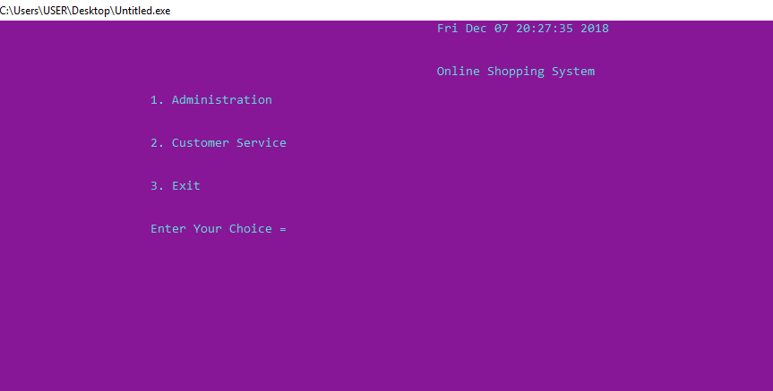

Here admin will log in with his password.

Page - 6

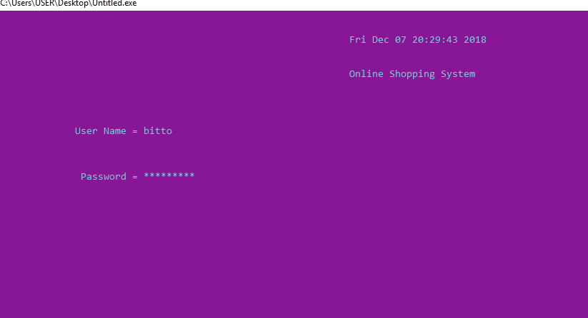

**1.1 ADMIN**

1. Add product
2. Available product list
3. Information
4. Exit

Admin will add product (A) like computer product, electrics product, cloths, shoes and also see available product (B). Admin see customer buying information (C). Admin will exit (D) from the software in any time.

Page – 7

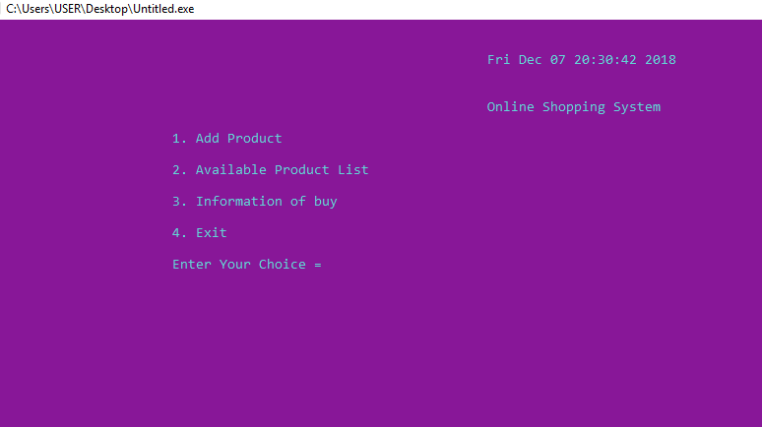

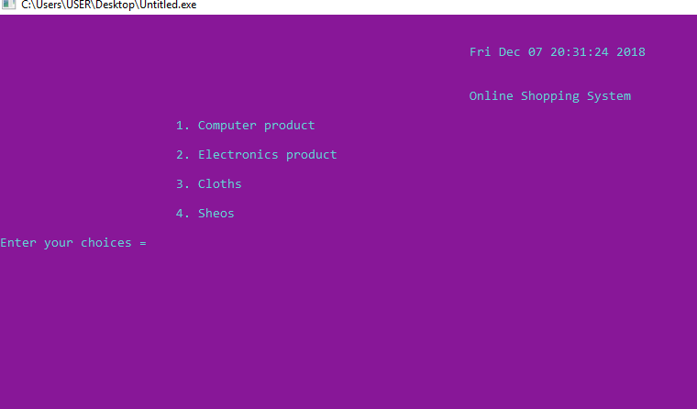

Page – 8

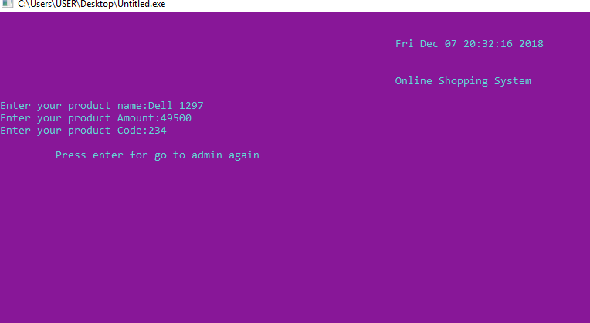

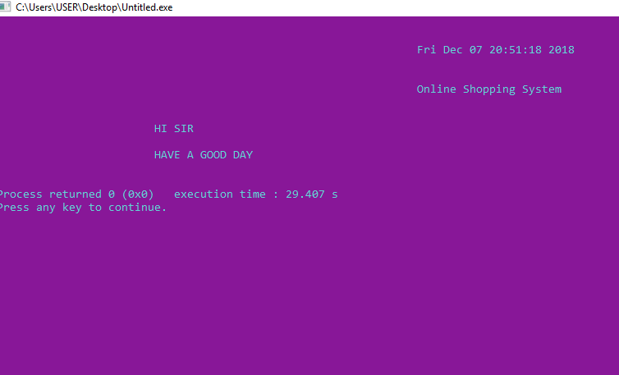

Page – 9

**1.2 CUSTOMER**

1. Visitors
2. Sign in
3. Sign up

Visitors (A) will only see the available product. Customer will create an account for buy product in signup (C). After sign up they will sign in (B) for buy product. They will select which method they will pay for buy and they will give from where they will collect product.

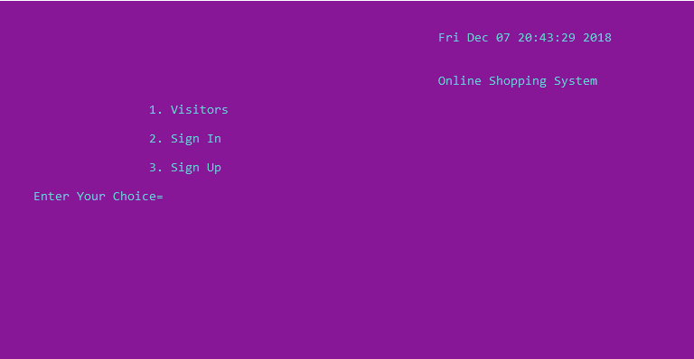

Page – 10

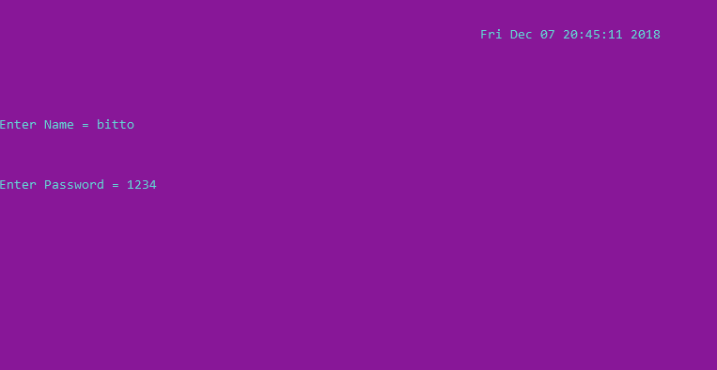

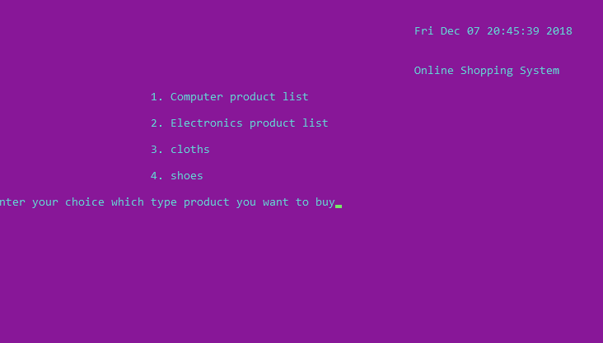

Page – 11

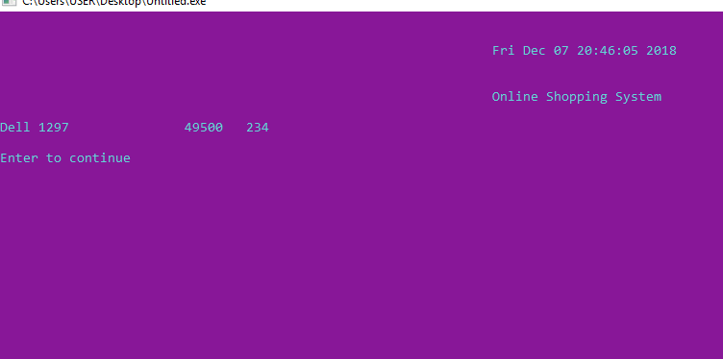

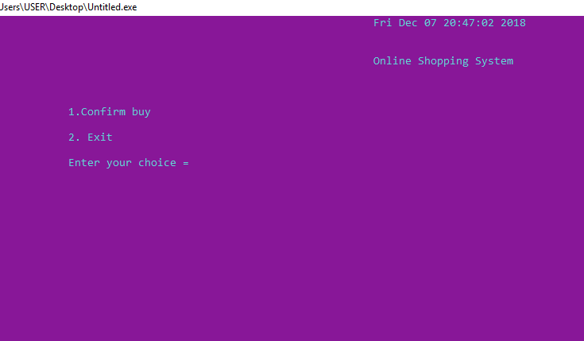

Page – 12

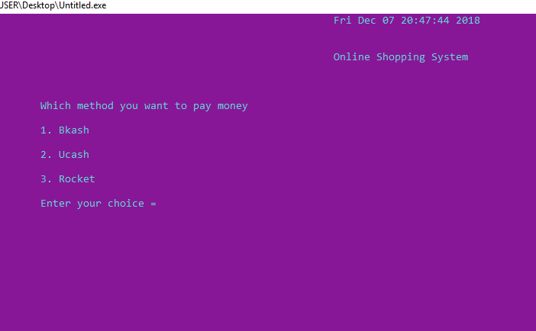

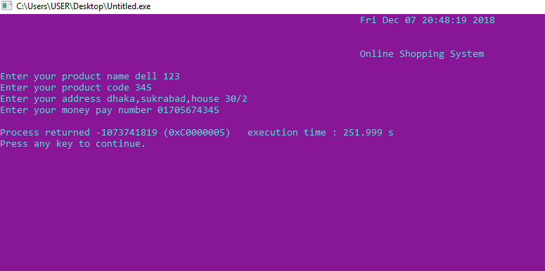

Page – 13

**1.3 EXIT**

Customer will exit from the software in any time.

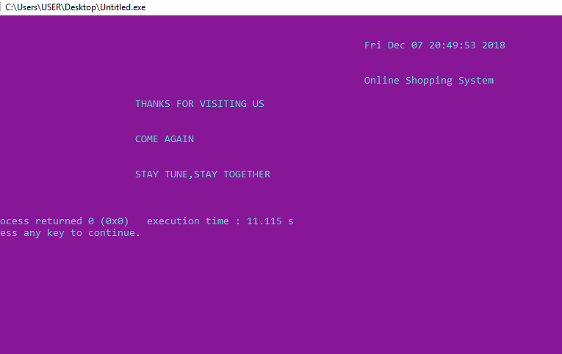

Page – 14

**2. DESIGN AND IMPLEMENTATION**

**Software language used**

* C language

**File management**

In my project I have used a lot of files to manage and store the data, I have created a separate file for every function I added to my project.

Page – 15

**3. SOFTWARE REQUIREMENT SPECIFICATION**

I collect the requirements from all stakeholders and here I specify all requirements in below:

|  |  |  |  |  |
| --- | --- | --- | --- | --- |
| SRS id | Title | Description | Requirement type | Priority |
| E.k -001 | Log in | Allow to access to admin | FR | High |
| E.k-002 | Add product | Add product for sell | FR | High |
| E.k-003 | Available | See the product that’s are added | FR | Medium |
| E.k-004 | Sign in | Sign in for buy | FR | High |
| E.k-005 | Sign up | Create account for sign in | FR | High |
| E.k-006 | Confirm buy | Select method which method they buy | FR | High |

Page – 16

**4.USE CASE**



Page – 17

**5.USE CASE DESCRIPTION**

|  |  |  |
| --- | --- | --- |
| Use case | Log In | |
| Goal | Get to the admin section | |
| Preconditions | N/A | |
| Success End  Condition | Successfully log in to the admin with correct name and password | |
| Failed End  Condition | Get the name and password 4 time. If failed then go to main funtion | |
| Primary Actors | Admin | |
| Secondary Actors | N/A | |
| Trigger | N/A | |
| Description / Main  Success Scenario | Step | Action |
| 1 | Successfully log in |
| 2 | See admin things |
| 3 |  |
| Alternative Flows | Step | Branching Action |
| 1 |  |
| 2 |  |

Page – 18

|  |  |  |
| --- | --- | --- |
| Use case | Add Product | |
| Goal | Add product for sell. | |
| Preconditions | N/A | |
| Success End  Condition | Product will add and you can see at available list | |
| Failed End  Condition | You can not see in the the available list | |
| Primary Actors | Admin | |
| Secondary Actors | N/A | |
| Trigger | N/A | |
| Description / Main  Success Scenario | Step | Action |
| 1 | Successfully Add |
| 2 |  |
| 3 |  |
| Alternative Flows | Step | Branching Action |
| 1 |  |
| 2 |  |

Page – 19

|  |  |  |
| --- | --- | --- |
| Use case | Available Product | |
| Goal | See all add product list | |
| Preconditions | First have to add product | |
| Success End  Condition | N/A | |
| Failed End  Condition | N/A | |
| Primary Actors | Admin | |
| Secondary Actors | N/A | |
| Trigger | N/A | |
| Description / Main  Success Scenario | Step | Action |
| 1 | See product list |
| 2 |  |
| 3 |  |
| Alternative Flows | Step | Branching Action |
| 1 |  |
| 2 |  |

Page – 20

|  |  |  |
| --- | --- | --- |
| Use case | Information Customer buy | |
| Goal | See which customer order which product and from where they collect product and which number from customer pay. | |
| Preconditions | First customer have to order | |
| Success End  Condition | N/A | |
| Failed End  Condition | N/A | |
| Primary Actors | Admin | |
| Secondary Actors | N/A | |
| Trigger | N/A | |
| Description / Main  Success Scenario | Step | Action |
| 1 | See customer information |
| 2 |  |
| 3 |  |
| Alternative Flows | Step | Branching Action |
| 1 |  |
| 2 |  |

Page – 21

|  |  |  |
| --- | --- | --- |
| Use case | Visitors | |
| Goal | See only the product | |
| Preconditions | First admin have to add product | |
| Success End  Condition | N/A | |
| Failed End  Condition | N/A | |
| Primary Actors | Customer | |
| Secondary Actors | N/A | |
| Trigger | N/A | |
| Description / Main  Success Scenario | Step | Action |
| 1 | See all product |
| 2 |  |
| 3 |  |
| Alternative Flows | Step | Branching Action |
| 1 |  |
| 2 |  |

Page – 22

|  |  |  |
| --- | --- | --- |
| Use case | Sign Up | |
| Goal | Create account for sign in | |
| Preconditions | A correct name that no one create account with that name | |
| Success End  Condition | N/A | |
| Failed End  Condition | N/A | |
| Primary Actors | Customer | |
| Secondary Actors | N/A | |
| Trigger | N/A | |
| Description / Main  Success Scenario | Step | Action |
| 1 |  |
| 2 |  |
| 3 |  |
| Alternative Flows | Step | Branching Action |
| 1 |  |
| 2 |  |

Page – 23

|  |  |  |
| --- | --- | --- |
| Use case | Sign In | |
| Goal | Get to the customer zone for buy product | |
| Preconditions | First have to sign up | |
| Success End  Condition | Successfully log in to the customer zone | |
| Failed End  Condition | First have to sign up | |
| Primary Actors | Customer | |
| Secondary Actors | N/A | |
| Trigger | N/A | |
| Description / Main  Success Scenario | Step | Action |
| 1 | Successfully log in to customer |
| 2 | See buying product |
| 3 |  |
| Alternative Flows | Step | Branching Action |
| 1 |  |
| 2 |  |

Page – 24

|  |  |  |
| --- | --- | --- |
| Use case | See Product | |
| Goal | See all product for buy | |
| Preconditions | N/A | |
| Success End  Condition | N/A | |
| Failed End  Condition | N/A | |
| Primary Actors | Customer | |
| Secondary Actors | N/A | |
| Trigger | N/A | |
| Description / Main  Success Scenario | Step | Action |
| 1 | See all product |
| 2 |  |
| 3 |  |
| Alternative Flows | Step | Branching Action |
| 1 |  |
| 2 |  |

Page – 25

|  |  |  |
| --- | --- | --- |
| Use case | Select Confirmation Method | |
| Goal | Which method from customer pay | |
| Preconditions | N/A | |
| Success End  Condition | N/A | |
| Failed End  Condition | N/A | |
| Primary Actors | Customer | |
| Secondary Actors | N/A | |
| Trigger | N/A | |
| Description / Main  Success Scenario | Step | Action |
| 1 | See payment method |
| 2 |  |
| 3 |  |
| Alternative Flows | Step | Branching Action |
| 1 |  |
| 2 |  |

Page – 26

|  |  |  |
| --- | --- | --- |
| Use case | Bkash | |
| Goal | Payment method for customer | |
| Preconditions | N/A | |
| Success End  Condition | N/A | |
| Failed End  Condition | N/A | |
| Primary Actors | Customer | |
| Secondary Actors | N/A | |
| Trigger | N/A | |
| Description / Main  Success Scenario | Step | Action |
| 1 |  |
| 2 |  |
| 3 |  |
| Alternative Flows | Step | Branching Action |
| 1 |  |
| 2 |  |

Page – 27

|  |  |  |
| --- | --- | --- |
| Use case | Ucash | |
| Goal | Payment method for customer | |
| Preconditions | N/A | |
| Success End  Condition | N/A | |
| Failed End  Condition | N/A | |
| Primary Actors | Customer | |
| Secondary Actors | N/A | |
| Trigger | N/A | |
| Description / Main  Success Scenario | Step | Action |
| 1 |  |
| 2 |  |
| 3 |  |
| Alternative Flows | Step | Branching Action |
| 1 |  |
| 2 |  |

Page – 28

|  |  |  |
| --- | --- | --- |
| Use case | Rocket | |
| Goal | Payment method for customer | |
| Preconditions | N/A | |
| Success End  Condition | N/A | |
| Failed End  Condition | N/A | |
| Primary Actors | Customer | |
| Secondary Actors | N/A | |
| Trigger | N/A | |
| Description / Main  Success Scenario | Step | Action |
| 1 |  |
| 2 |  |
| 3 |  |
| Alternative Flows | Step | Branching Action |
| 1 |  |
| 2 |  |

Page – 29

**CHAPTER 3: CONCLUSIONS AND RECOMMENDATIONS**

Online Shopping System a modern thing for people so that they can buy their valuable thing with saving money and time. Its help to save their valuable time. People have to go to the market with lost valuable time. They have to go one shop to other for select right product.it also effect to body tiredness. Online shopping system help to save their time and extra money and tiredness. It’s have more variety. May be that will help all people.

RECOMMENDATIONS FOR FUTURE WORKS

Alhamdulillah finally I have successfully completed my project, I have a lot of aspects in future plan now this is only software but I want to convert it in a real and working project also I want make a new design for my project so it will look more attractive in addition to that I am going to add extra features in the project and it will be more helpful and effective.

**REFERENCES**

1. Teach yourself C by Herbert Scheldt
2. Data structure with C by Seymour Lipchitz

Page - 30